User’s Guide

This document establishes the proper operating procedures for each module of the File Transfer Service defined by the C2, FTS, and FSS programs located in this repository.

Command and Control (C2) Module

The C2.py file within the bin directory operates the Command and Control module. Written in python, this module executes the session initiation and file transfer from the host client to the File Storage System through the File Transfer System. The C2 program takes an encoding pattern, a pass phrase, a destination File Storage System address and port, a file name to identify the file on the FSS, and a path to the file to transfer. These inputs can be specified on the command line, or the program can run in interactive mode and prompt the user for them. It also supports an option to enable more verbose output, and output the help menu from the screen shot below (cropped for legibility):

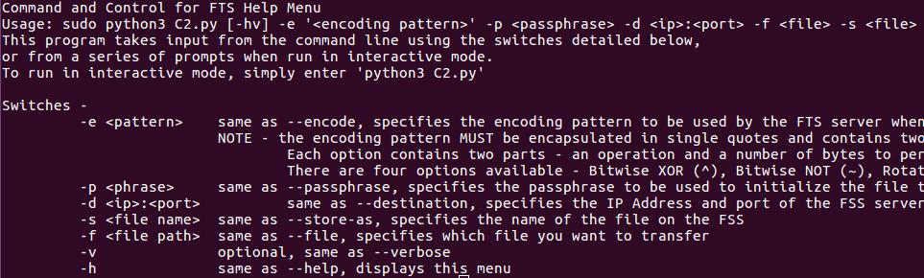
The following screen shot details program initiation both interactively and from the command line to send the file /etc/passwd to the File Storage System located at 127.0.0.1 and listening on port 65535 using the encoding pattern ~:2;~:2, pass phrase “passphrase”, and stored as sent_passwd:

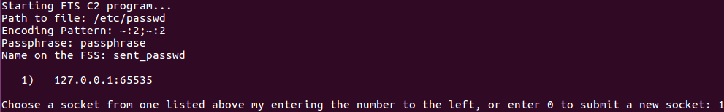
As shown in the screen shots above, when run interactively the C2 program prompts the user to choose a socket from an approved list stored in the IPAddWhiteList file in the bin directory. This file contains a list of valid File Storage System addresses and ports and their accompanying encoding patterns. As shown above, when run interactively the C2 will query the IPAddWhiteList and only enable the selection of those addresses that match the encoding pattern. When there are no entries for an encoding pattern, the program will prompt the user for a socket as shown in the screen shot below:
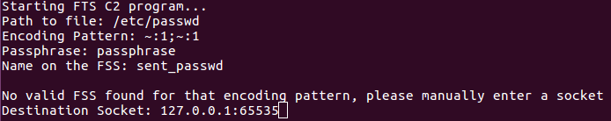
When using a custom socket, the C2 will attempt to establish a connection with the specified File Storage System. If successful, the C2 will add that File Storage System to the IPAddWhiteList for use in future transfers.

After the program has received and validated all of its inputs, it attempts to connect to the File Storage System through the File Transfer System over UDP. If the File Storage System receives the request, it will send one of two possible responses back to the C2. In the first case, the filename specified by -s or by the “Name of the FSS” prompt is available and the C2 will commence the TCP transfer immediately. In the second case, the specified file name is not available and the C2 will prompt for a new file name, demonstrated in the screen shot below:

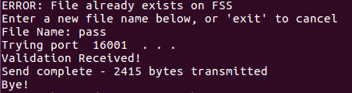

Once the user provides an available file name, the C2 program conducts the transfer of the specified file over TCP and exits.

File Transfer System (FTS) Module

The FTS binary file within the bin directory operates the File Transfer Service module. Written in C, the FTS program is mainly defined by the fts.c file within the src/sources directory. The FTS program takes no input, but supports a limited command prompt useful in administering the server.

Unique to this module, the FTS is multi threaded, enabling it to manage many different transfers at the same time. The FTS program manages three separate classes of threads. The first thread supports the limited command line used for administering the server. This thread enables administrators to query the log, determine the number and status of the other threads, and securely close the thread. The limited prompt supports the following commands:

- search <term> - This command searches the encoded log for the FTS and returns any lines that match the term.
- head <num> - This command returns the last <num> entries of the encoded FTS log.
- status - This command returns the number of active connections and the status of the listener thread, which can be used to indicate an fatal error that requires a program restart.
- exit - This command supports graceful exit from the server by preventing new transfers, ensuring all active transfers finish, and ensuring that all resources get freed.

The second thread class is the listener thread. This thread creates UDP sockets on ports 16000 to 17000 and monitors them for incoming packets. When the server receives a packet, it captures any pertinent information and creates a new thread to handle the information. This thread remains active until the main thread tells it to stop accepting connections.

The third thread class is the transfer session thread. The listener thread creates these in response to incoming UDP packets and empowers them to handle every aspect of a file transfer, including all UDP packet types and the TCP transfer itself. These threads also log the results of its transfer in the FTS log that the main thread can query through the command prompt.

The screen shot below details the operation and output of each of the commands the FTS supports.

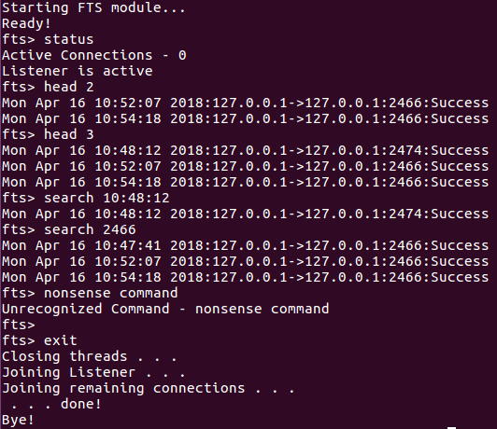

File Storage System (FSS) Module

The FSS.py file within the bin directory defines the File Storage System module. The FSS runs on each machine designated to store files in support of the file transfer system. Written in python, the FSS program takes an encoding pattern to use in support of its communications with the FTS module, a local port to listen on for incoming connections, and optionally a destination directory used to store all of the files it receives. It also supports an option to enable more verbose output from the FSS program. These options are outlined in the image below:

All three commands will start the FSS on local port 65535 using the encoding pattern ‘~:2;~:2’. The first and second commands specify that all of the files this FSS receives will be stored in the directory /files, and the first enables verbose output. The third command, having not specified a destination directory, will default to the current working directory.

In addition to the command line option, the FSS also supports prompted input detailed in the screen shot below.

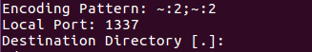

The FSS is relatively self-contained – excluding the output provided by the program, it is able to operate autonomously and handle any packets it receives. The screen shot below details the verbose output of the FSS. When run without the verbose option, the FSS display no output.

